**Team 2 Proposal - Foodbulous**

* **INTRODUCTION**

介绍产品，公司，组

* **MARKET ANALYSIS—RIVAL**

Openrice is the industry key player of Hong Kong food review websites. After meeting with Keith, it is ensured that foodbulous does regard openrice as its main rival.

1. Overview

* More than 3 million monthly users
* 83 million-page views,
* More than 450,000 registered members
* 500,000 reviews.
* Ranks 29th on the entire Hong Kong website, with about 66% of traffic coming from Hong Kong.
* Has more than 41,000 restaurants in Hong Kong, Macau and Shenzhen (Hong Kong accounts for 21,000)

2. Problems

1. For restaurant seekers

* the restaurant recommended by Openrice is not delicious.
* Too many comments are made by ‘打手’.
* The Openrice app is full of advertisements, affecting users' feeling.

2）For reviewers

* They need to wait for ‘moderate’, and they don't know how long to wait.
* Their bad reviews may be blocked.
* The KOL group on Openrice has been finalized, and it is difficult for newcomers to become famous.

As Keith said, no one likes Openrice. This gives Foodbulous a chance to solve the problems brought by Openrice and meet the needs of users that Openrice can't meet.

* **PRODUCT ANALYSIS**

1. **Mission**

“How to find good food” is a troublesome question in everyone’s daily life. Foodbulous provides a reliable way to help explore food and find what they want to eat. Also, through Foodbulous, people will restore beliefs and passions towards food.

social functions, friends network

**2. SWOT analysis**

1) Strengths:

For users:

● **Emphasis on the interactions between friends**: After registering a Foodbulous account with Facebook, users can see those restaurants and related food reviews recommended by their friends in Foodbulous's "Dynamic News" column. At the same time, after writing a food review in Foodbulous, users can also share it share it with more friends through Facebook.

● **Few fake reviews in Foodbulous**: OpenRice hires a lot of people to write fake information, and many of the search results and evaluations in OpenRice are untrustworthy. The evaluation of Foodbulous is freely released by users and has higher credibility.

●  **"Deck(食組)" function is added to allow users to better manage and browse their favorite restaurants**

有创新点, 餐厅收藏夹

For the store:

● Support small stores, no recommendation fees: For restaurants, in addition to registration on Openrice, other services generally need to pay, and the cost is very expensive. Different from Openrice, Foodbulous promotes the restaurant in a freeway. Although the app is also maintained by advertising, it insists that no advertising fees will be charged to restaurants.

● Managers have the opportunity to tell the story behind the store: As mentioned by Keith, Foodbulous not only pays attention to the restaurants ' special dishes, but also intends to know the story behind the restaurants.

2) Weaknesses：

● The database is incomplete and the update is slow. The last update was in 2017, and the number of restaurants that can be searched on the app is limited.

● The propaganda channel is narrow. It is difficult to let more users know the app only through the propaganda of acquaintances. And Foodbulous's social media account is not operated well and has no attractive content.

● The software is not user-friendly and the content is too fragmented and complicated. The structure is confusing, and it is difficult for users to find the content they need.

● At present, the scale of users is too small to collect data. And there is no contact channel such as the user's mailbox to push information to users, so it is difficult to establish a user database.

3) Opportunities:

● The catering industry in Hong Kong is developing rapidly. Correspondingly, catering-related software also has great room for development.

● Consumers are diverse. A large number of users are tired of Openrice's false comments and are looking for new apps to find good restaurants.

● The successful experience of the Mainland can be applied to the Hong Kong market and can be internalized and adjusted according to the user habits of Hong Kong people.

4) Threats:

● Fierce competition: Openrice is dominant in the industry, which squeezes the development space of the new app.

● Similar apps: such as Eatchoice and iPick, whose main design idea is to share the food information with friends.

**3. USP**

1) Recommendations based on friends’ reviews: More reliable and persuasive compared to data provided by restaurants

2) Interactions with other foodies: through likes on food reviews (but no comments)

3) Collections of favorite food or restaurants: decks (but too complicated)

**4. Product Features**

There are five pages on Foodbulous: News Feed, Discover, Restaurant, Foodie and Profile

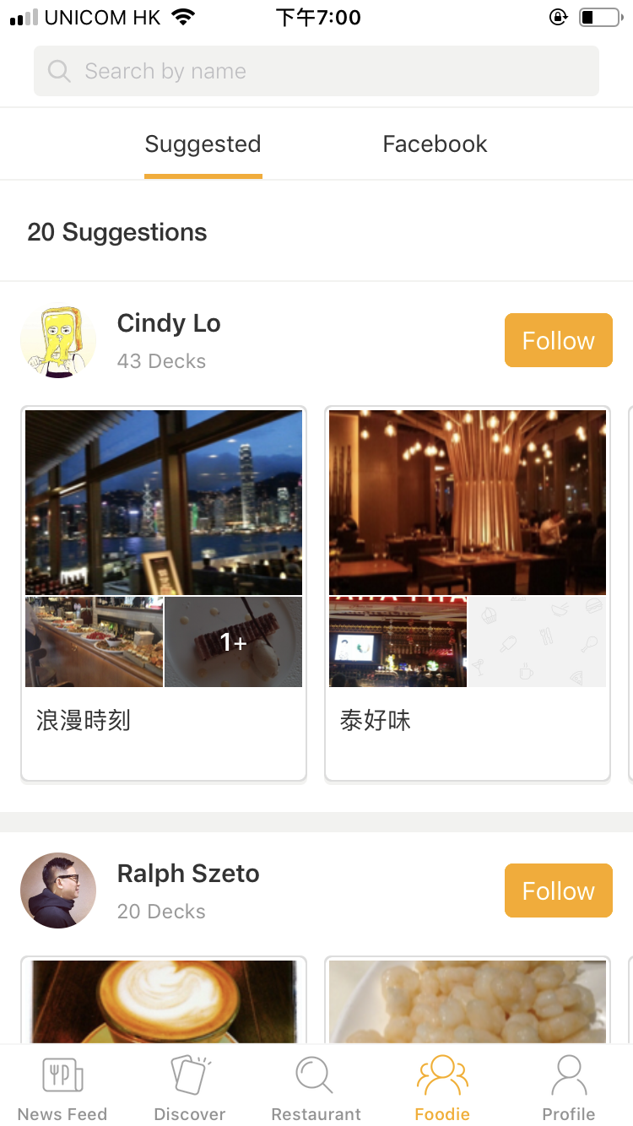

In order to better introduce their contents, we group these pages according to their functions:

1) Social Function Pages:

---Foodie,  News Feed and Profile

①Foodie Page: Showing a list of users one could follow on Foodbulous.

--- Includes suggested stranges and automated loaded-in facebook friends

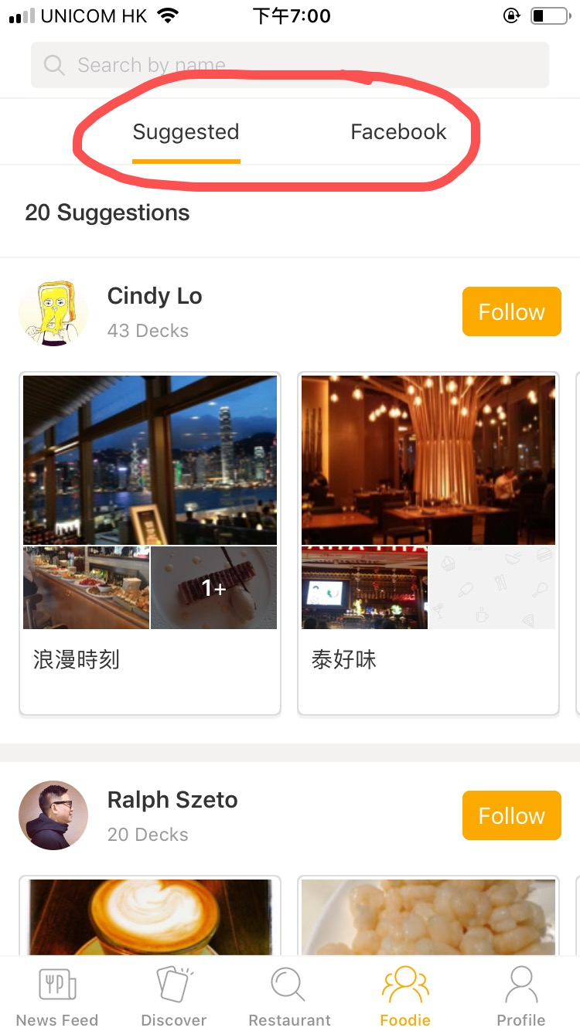 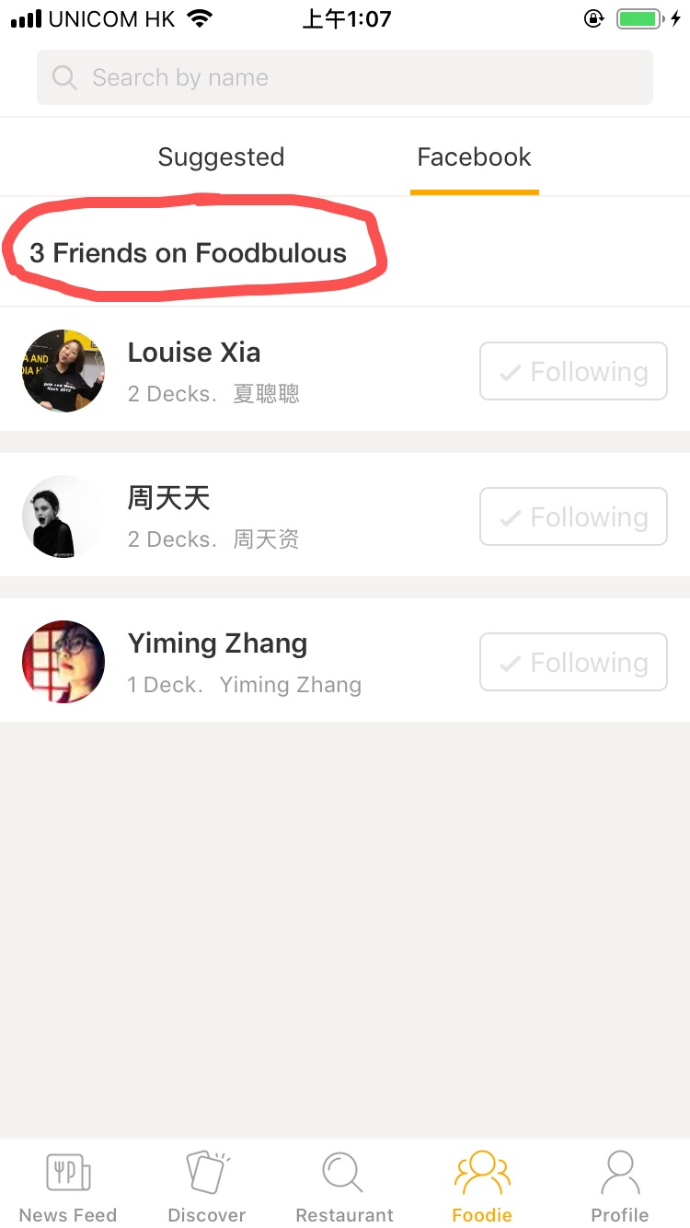

② News Feed Page: Food reviews posted by the users one follows

--- Views of uses’ friends will be shown on the top

--- In the latest app version, users can like or share others’ posts, but not making comments or reply

--- Each food review links to a single page of the restaurant

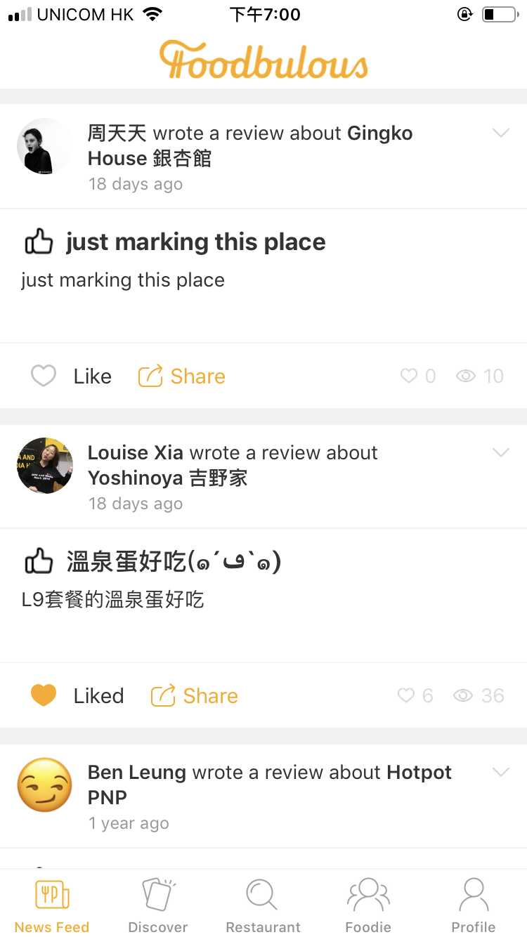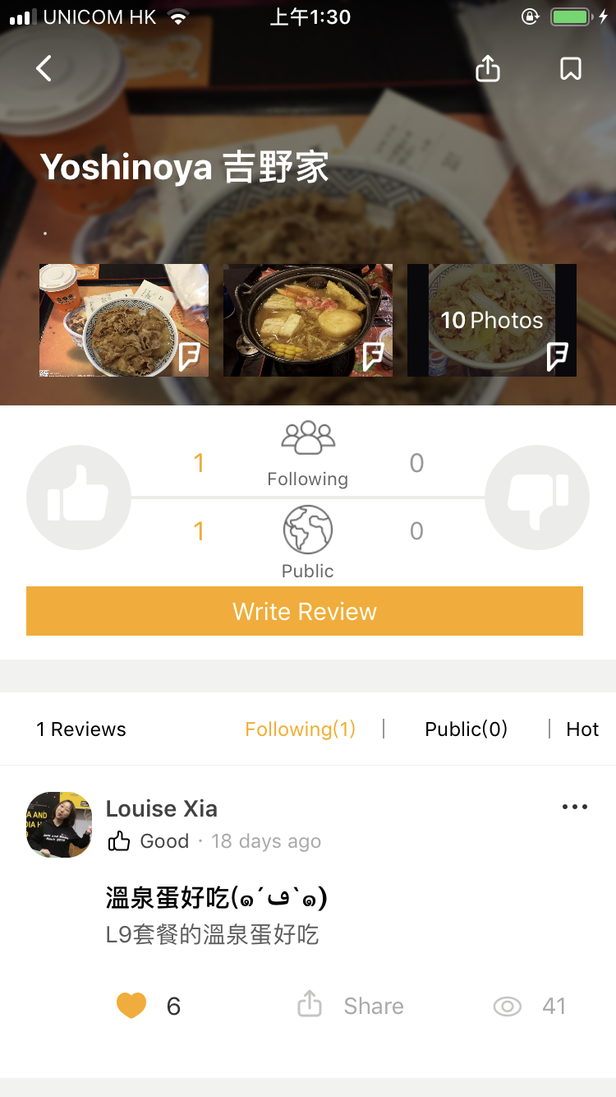

③ Profile Page: Users’ own profile page

--- Displaying users’ ”favorite desks” of restaurants (the restaurants that you marked)

--- User can build, name their desks(favorite restaurant lists) freely, and tag them with different theme, district and dish labels.

--- Showing one’s following and followers number

--- Food reviews are not directly shown on this page

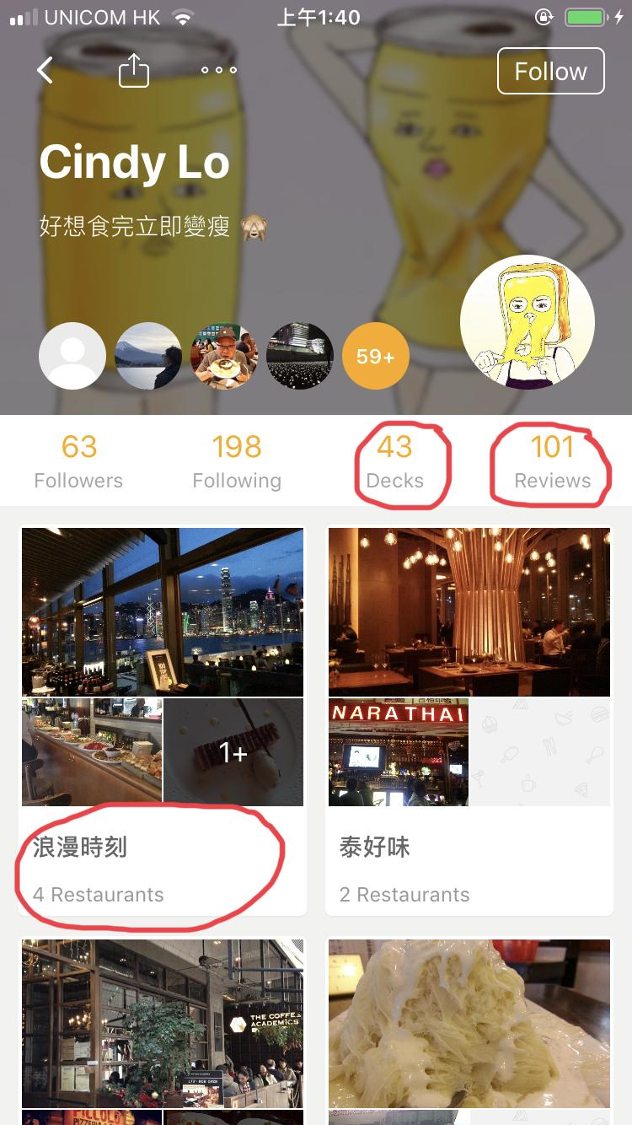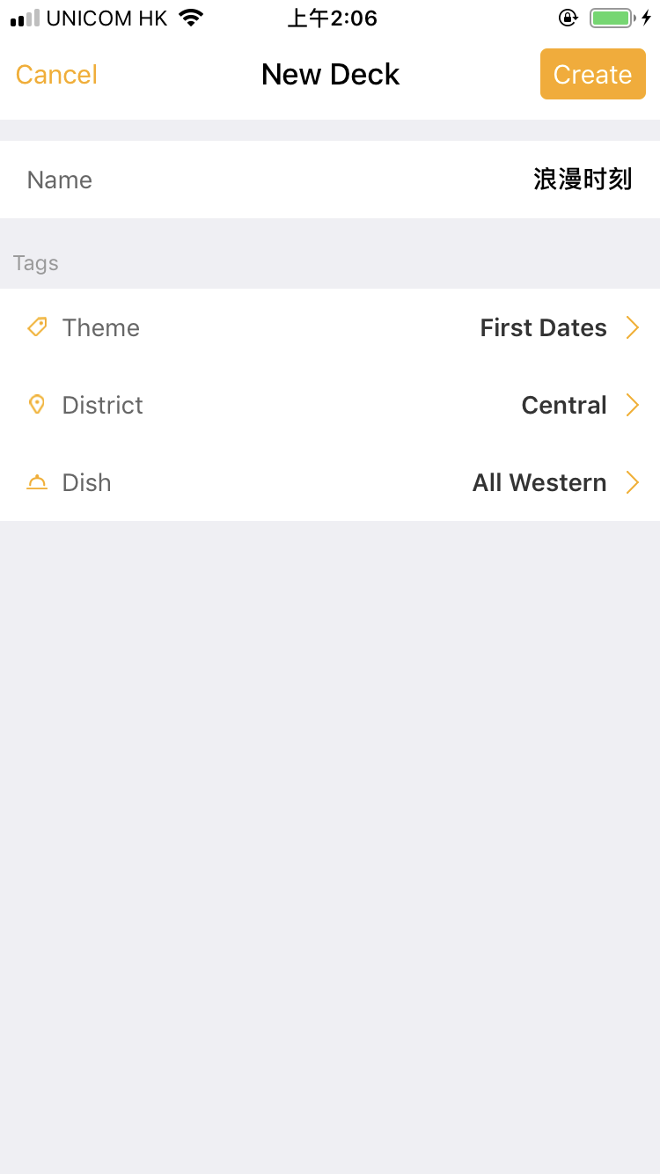

**Connection:**

--- Food review is the core link between user network and restaurant database.

2) Search Restaurant Function Pages:

* Discover and Restaurant

①Discover Page: Theme-based Restaurant Searching System

--- Displaying a number of themes cards of different styles of restaurants

--- Users can apply three filters: theme, district and dish to find the proper restaurant they need

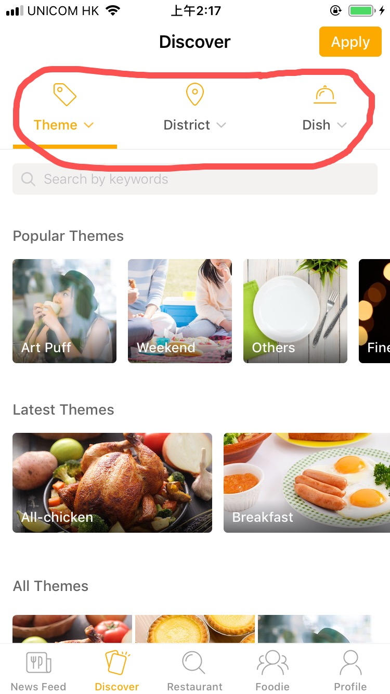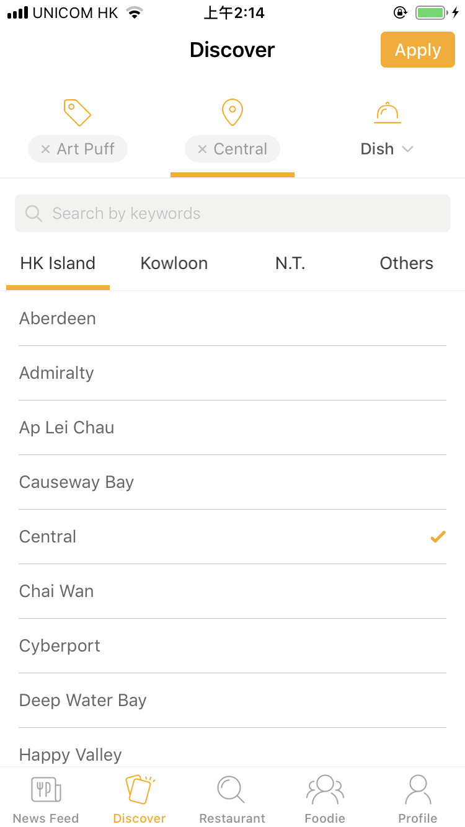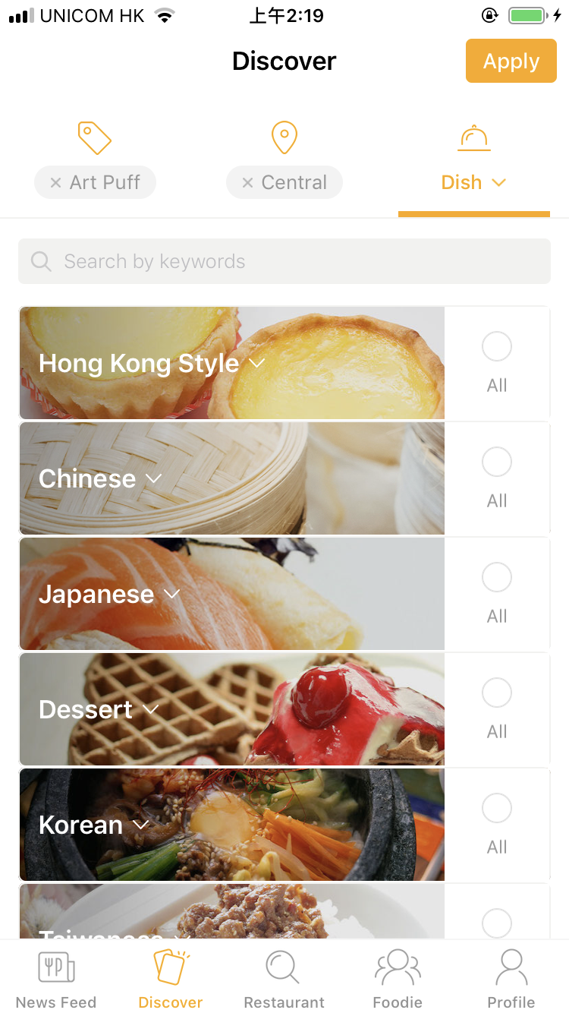

②Restaurant Page: Direct Search of restaurants

--- User can use the two top search bars to search restaurants by names or districts

--- Each result record have the restaurant name and address, but no price and foodtype

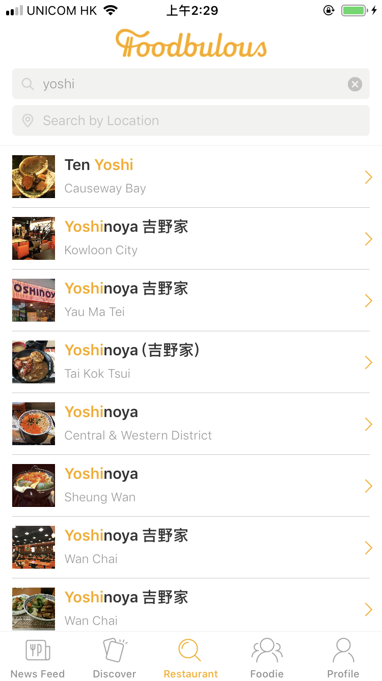 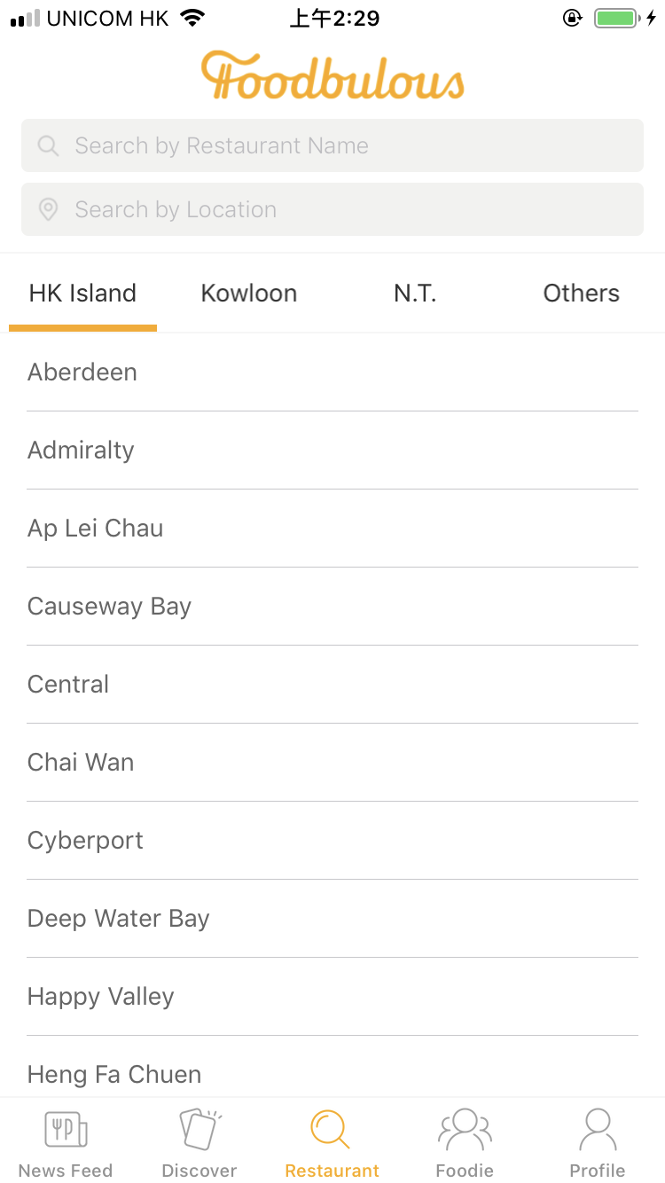

③ Restaurant single page:

--- Basic information of the restaurant

--- Rate and review are displayed in two separate channels: Friends and Pubic(other users)

--- Rating system: only like(thumb up) and dislike(thumb down), no five star rating system

--- User can click on the stamp button in the top right corner of the screen to collect this restaurant into their decks

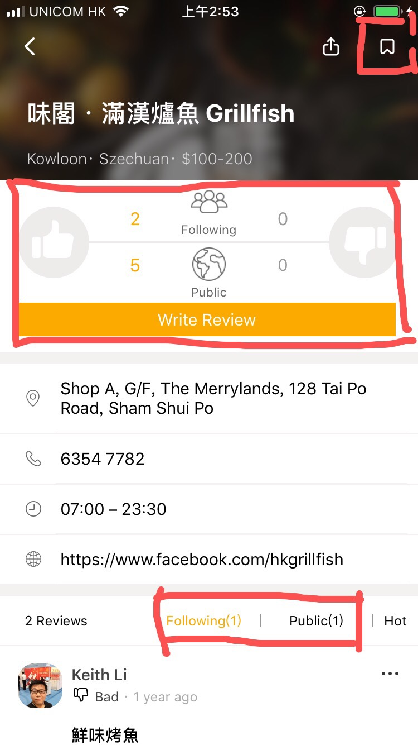

**[Summary] Major user journey:**

--- Using theme cards or direct search to find a restaurant --> read friends’ and public’s reviews --> choose a restaurant to visit --> rate and review

**5. Current Business Model:**

According to Keith, they want to solve the problem of too many fake reviews(people being paid to promote certain restaurants and badmouth their competitors) and advertisements on OpenRice, so they won’t take any advertisements from restaurants.

However, they are open to advertisements from other business related to the catering industry, such as credit cards, food ingredients and kitchenware, which might become their future revenue source.

* **PROBLEMS—with UX elements paradigm**

|  |  |
| --- | --- |
| **Problems** | **Reasons** |
| 1. Too many functions: none is outstanding, hard to use | intern team members failed to reach a consensus |
|  |  |
|  |  |

**1. The Strategy Plane**

1) Site Objectives

- According to Keith, the App was designed and developed by an intern team where people with diverse backgrounds and want to present their own ideas in one product. (introduction)

Too many functions but none of them is outstanding enough to make the product distinguishable.

- Reason: The team members fail to reach a consensus before design the app.

2) User Needs

- Although the team identify the user pain points as mentioned before, they were not clear about what problems they want to solve and how to solve.

Conclusion: lack of deep consideration in the strategy plane.

**2. The Scope Plane**

1) Functional Specifications

- The objectives of each functions are not specific.

- Too many functions can distract the users.

- The relations between the functions are not very clear.

2) Content Requirements

- Lack of data of the restaurants.

- The app is supposed to contain most of the restaurants in HK, however, many restaurants cannot be founded after our testing.

- After applying all the conditions in the “discovery” functions, it turns out nothing in most cases. It can be implied that the data is not enough to support all the filters.

- Lack of data of the users. Keith mentioned a great regret that the app did not designed a place to collect the data from the users, especially the emails. So, it is hard for Foodbulous backend to analyse the users and develop marketing campaign.

- At the very beginning, an app needs a long time to precipitate users, so the designers themselves need to provide more content to make the app looks “rich”. However, the official account just presents a little information, which make the app looks “lean”.

Conclusion: the logic behind the functions are not clear.

**3. The Structure Plane**

1) Interaction Design

- Some interactions are not reasonable.

- Landing page: the default landing page is the “Moments” where show the users’ friends posts. But for the first users (who have not followed any friends), the page is totally blank without any reminders or buttons to call actions.

- Discovery: after clicking the button, the users expect to see the restaurants directly. But in foodbulous, the users have to click the button on the tight-top to “apply” the conditions.

- Usually flashback (suddenly end the program when the user acted frequently)

2) Information Architecture

- The categories of food are unclear and not attractive. It is hard for users to interpret the real meaning just for the name such as 「是但啦」/「极邪恶」,etc.

**4. The Skeleton Plane**

1) Interface Design/Navigation Design

- No “comments” function. According to Keith, one of the most important features of Foodbulous is to let users share good food with their friends. Now Foodbulous only allow people to “like” and “repost” but we think “reply” is also initial to social networking.

2) Information Design

- The secondary list of 「菜式」is missing

**5. The Surface Plane - Visual Design**

- Most of the pictures are low-quality and unattractive. The quality of food pictures is very important for a food app to maintain the users and attract new users.

Notes: Since all the interns who designed the app have left the company without leaving any materials. All the problems mentioned above are concluded from our own user experience and Keith’s introduction.

* **OBJECTIVE**

To improve the usability of Foodbulous

To increase the downloads and the number of users

* **STRATEGY & SOLUTION**

1. UX Redesign

To make Foodbulous easy to use, our team plan to redesign the user experience based on user journey. We are going to reorganize the workflow of each section by focusing on “food review” part—the bridge between users and restaurants.(三角關係圖)

1. Food seekers (normal users):

search for food or restaurant → see food reviews → find relevant food, favorite folders (deck), restaurants → discover and mark good food → discuss with reviewers and other foodies

1. Food review writers (potential KOLs):

write remarks, upload photos, rate the food → publish food reviews → categorize to favorite folders (deck) → discuss with other foodies

**Current Major user journey:**

--- Follow Foodies --> Read their posts --> Learn about an interesting restaurant -->stamp the restaurant --> From a deck

--- Being asked to recommend some restaurants --> send a restaurant deck to the friend

1. UI Redesign

The new UI will be grounded on our App objective and attempts to facilitate the user journey by improving the old version in the following three dimensions:

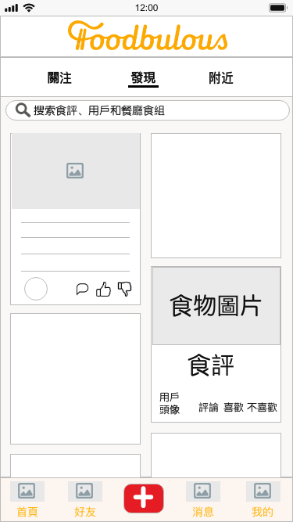

**New UI Sample (Prototype) Current UI**

① To enhance the social and community attribute of Foodbulous

--- By placing user-generated food and/or restaurant Reviews (食評) on the Homepage with big and fantastic pictures;

--- By introducing “comment”, “like” and “dislike” functions to each Food Review to increase interactivity between users;

--- By enabling users to store, like, comment others’ Decks (食組) and share them to other social media platforms;

② To improve usability of Foodbulous and increase user’s agency

--- By displaying “Writing Reviews (寫食評)” in a conspicuous place (i.e. navigation bar at the bottom), where users can easily find once they want to post Notes;

--- By replacing ambiguous wordings (e.g. “空腹食早餐”, “男人的浪漫”, “偉大的媽媽”...) with more explicit and directed ones to avoid confusion;

--- By transforming “Restaurant (搜索餐廳)” tab to a multipurpose search bar, which is fixed at the top of every tab page;

--- By integrating “Popular Themes (卡牌)” into search bar as tag suggestions (標籤聯想提示) with reference to 小紅書, and offering Autocomplete Suggestions with reference to Google

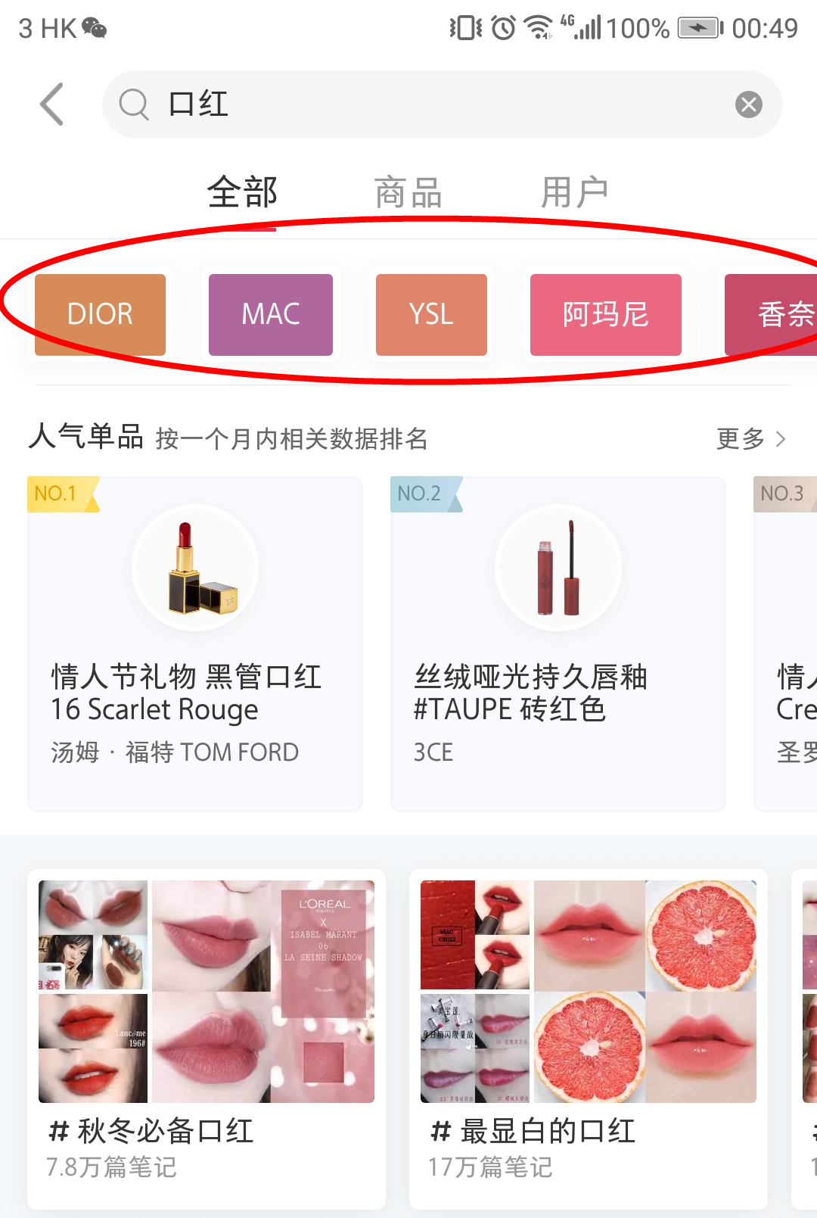

小紅書Tag suggestions

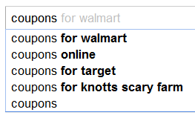

Google Autocomplete Suggestions

③ To strengthen the relationship between product (i.e App) and users

--- By adding more methods for logging in in addition to Facebook (e.g. Whatsapp, Instagram)

--- By creating sharable QR code and URL for users to invite their friends

3. Customer Redefine

谁是目标客户？

--- 全香港人？

--- 全香港会用手机搜餐厅的人？

--- 全香港对OpenRice感到失望并且仍然想用手机搜餐厅的人？

* **TESTING & EVALUATION**

1. KPIs

We have set several KPIs to evaluate the success of our UI/UX redesign

* 1. Downloads
* 2. Review Scores gained
* 3. DAU
* 4.
* 5.

2. Usability test; A/B test;

According to Keith, the redesigned products cannot be online immediately. So large-scale A/B test is difficult to carry out, and Keith believes that small-scale A/B test is meaningless. So in the testing phase, we will focus more on usability test.

Two measurement methods:

* scenario metrics
* experience scorecards

Three steps:

* Step 1: the wireframe will be printed on paper and the redesigned app will be simulated by cropping, pasting, and coloring.
* Step 2: some users will be invited to experience the app. And they will be placed in some scenarios, such as “write a review for Chan Kun Kee” or “find a delicious Italian restaurant”. In the process, their behavior will be recorded by video and will be measured and scored.
* Step 3: all the scores will be recorded in scorecards and the scores will be updated as the design is iterated. After the entire project is completed, the trendline can be drawn based on the score.

3. Qualitative Research: **Face-to-face Interview**

1) Objectives: understand the attitudes or mind-sets of a user, by asking for the “Why” and “How”.

2) Plan: deliver an interview with 5 people after every version of interactive prototype.

* **TIMELINE**+展望未来（Marketing）【周天资】

a. breakdown

Our team has confirmed with Keith that there will be two more meetings during the whole project period, so we decided to divide the whole process into three iteration cycles and present to him two deliverables for feedback.

In the first sprint, a lo-fi wireframe prototype will be built and used to conduct usability test and thus to verify whether our objectives can be achieved with the redesigned and reorganized features of Foodbulous.

The second sprint will include a hi-fi prototype with improved features. The second usability test will be carried out during the corresponding review phase for more tweaks in UI/UX of the third sprint.

Our project timeline throughout the whole semester would be as follow:

For the next step, our team is going to conduct exploratory user research (face-to-face interview as stated above) to gather requirements and utilizing user story mapping techniques to prioritize the features and divide them into chunk of sprints.

Please click here to check our project management Airtable page.

b. airtable